SEARCH FOOD RECALLS – Design Style Guide v1.2

The website page has the following frame/grid layout design

FOOTER AREA

SEARCH ENTRY AND RESULT AREA

WEB PAGE HEADER AREA

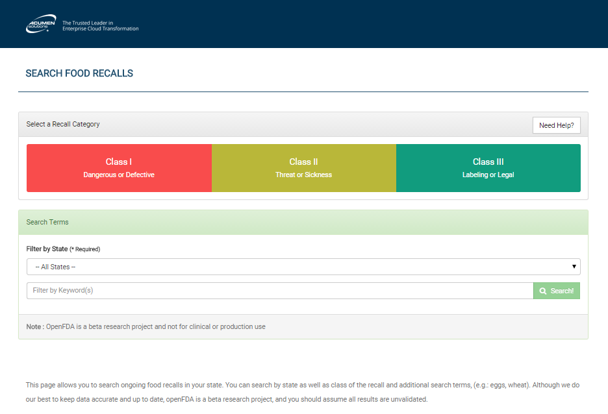

SEARCH ENTRY AND RESULT AREA

WEB PAGE FOOTER AREA

WEB PAGE HEADER AREA

Main Grid Sections of the Web Application

**GENERAL SPECIFICATIONS:**

**-Bootstrap and Angular JS:** Pattern Library and Design Guidelines are standard implementation and can be find at<http://getbootstrap.com/css/> **and** <https://github.com/johnpapa/angular-styleguide> (Open Source Content)

- **Dynamic size:** Grid areas dynamically resize based on user browser agent.

**- Min resolution:** The web app will support a minimum screen resolution of 320x320 pixels.

**- Font:** Roboto sans-serif

**-Font Icons:** Fontawesome

**-Image folder on GitHub:** [acumen-gsa-agile-prototype](https://github.com/AcumenSolutions/acumen-gsa-agile-prototype)/[public](https://github.com/AcumenSolutions/acumen-gsa-agile-prototype/tree/master/public)/**img**/

**-Favorite Icon:** [acumen-gsa-agile-prototype](https://github.com/AcumenSolutions/acumen-gsa-agile-prototype)/[public](https://github.com/AcumenSolutions/acumen-gsa-agile-prototype/tree/master/public)/[img](https://github.com/AcumenSolutions/acumen-gsa-agile-prototype/tree/master/public/img)/**favicon.ico**

**-Main CSS Style Sheets:** [acumen-gsa-agile-prototype](https://github.com/AcumenSolutions/acumen-gsa-agile-prototype)/[public](https://github.com/AcumenSolutions/acumen-gsa-agile-prototype/tree/master/public)/**stylesheets**

**HEADER AREA:** body > div.navbar.navbar-inverse.set-radius-zero



The header area contains a div table container with a dark blue navy background hex color: #003152 and logo image img/logo.png

**SEARCH AREA:** body > div.ng-scope

**Search Entry-Select a Recall Category and Search Entry-Search Terms entry:** body > div.ng-scope > div content-wrapper ng-scope

* **Need Help? button:** background #DBDBDB
* **Help Text:** linear-gradient(to bottom,#e8e8e8 0,#f5f5f5 100%)

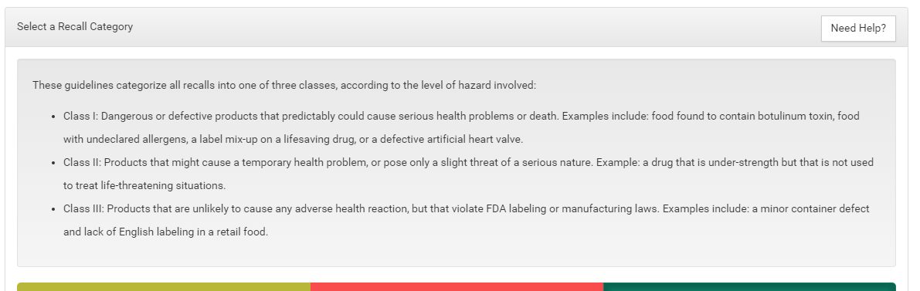

**Class Categories buttons:** body > div.ng-scope > div > div.container > div > div.row.in > div.panel.panel-default > div.panel-body > div.btn-group.btn-group-justified



* **Class I button:** #C73D3D box shadow #9F3131 **font** mouse over event #333 mouse out #FFF
* **Class II button:** #94922E box shadow #767525 **font** mouse over event #333 mouse out #FFF
* **Class III button:** #0E7D65 box shadow #0B6451 **font** mouse over event #333 mouse out #FFF

**Search Entry:**



* **On focus color:** #66AFE9 **box shadow** rgba(102, 175, 233, 0.6)

**Search Button:**



* **Button:** #5cb85c mouse over #419641 and Fontawesome search icon <i class="fa fa-search"></i>

**Search Result Area:**

* body > div.ng-scope > div content-wrapper ng-scope > div row
* body > div.ng-scope > div > div.row > div panel panel-default

**FOOTER AREA:** body > div.container.text-muted